Microcontroller Experiments using Arduino or MSP430:

a. Two colour LED

b. RGB LED

1. Two Color LED

The Two-Color LED stands as versatile component, offering a spectrum of colors and lighting effects within a single package. These LEDs, often known as bi-color or dual-color LEDs, allow for the emission of two distinct colors, enabling captivating lighting solutions and creative visual displays.

The Two-Color LED integrates two light-emitting diodes (LEDs) in one housing, each emitting a different color (typically red and green or red and blue). By controlling the current flow to each LED within the package, various colors can be produced, providing flexibility in lighting design.

Features and Functionality

* **Dual LEDs:** Houses two LEDs in a single package.
* **Color:** Green and Red.
* **LED Size:** 5mm.
* **Operating Voltage:**
  + **Red:** 1.9 ~ 2.2V.
  + **Green:** 2.3 ~ 2.6V.
* **Operating Current:** 20mA.
* **Luminous Intensity:**
  + Red: 60 ~ 80 millicandelas.
  + Green: 20 ~ 40 millicandelas.
* **Compatibility:**This module is also compatible with other devices like the Raspberry Pi, ESP32, and ESP8266 etc…

Components required:

* Arduino board (e.g., Arduino Uno)
* Two Color LED Module
* 220Ω Resistors - 2
* Breadboard
* Jumper wires

Pin Configuration

Connecting the Two-Color LED Module to an Arduino is fairly simple. The connections are as follows:

* **G** on the Two-Color LED Module to **GND** (Left Pin) Arduino.
* **R** on the Two-Color LED Module to **Digital pin 9** (Middle Pin) on the Arduino.
* **Y** on the Two-Color LED Module (Right Pin) to **Digital pin 10** on the Arduino

Program:

#define redPin 9 // Red LED pin

#define greenPin 10 // Green LED pin

void setup() {

pinMode(redPin, OUTPUT);

pinMode(greenPin, OUTPUT);

}

void loop() {

// Turn on red, turn off green (produces red color)

digitalWrite(redPin, HIGH);

digitalWrite(greenPin, LOW);

delay(1000); // Delay for 1 second

// Turn off red, turn on green (produces green color)

digitalWrite(redPin, LOW);

digitalWrite(greenPin, HIGH);

delay(1000); // Delay for 1 second

// Turn on both red and green (produces yellow color)

digitalWrite(redPin, HIGH);

digitalWrite(greenPin, HIGH);

delay(1000); // Delay for 1 second

// Turn off both red and green (LED is off)

digitalWrite(redPin, LOW);

digitalWrite(greenPin, LOW);

delay(1000); // Delay for 1 second

}

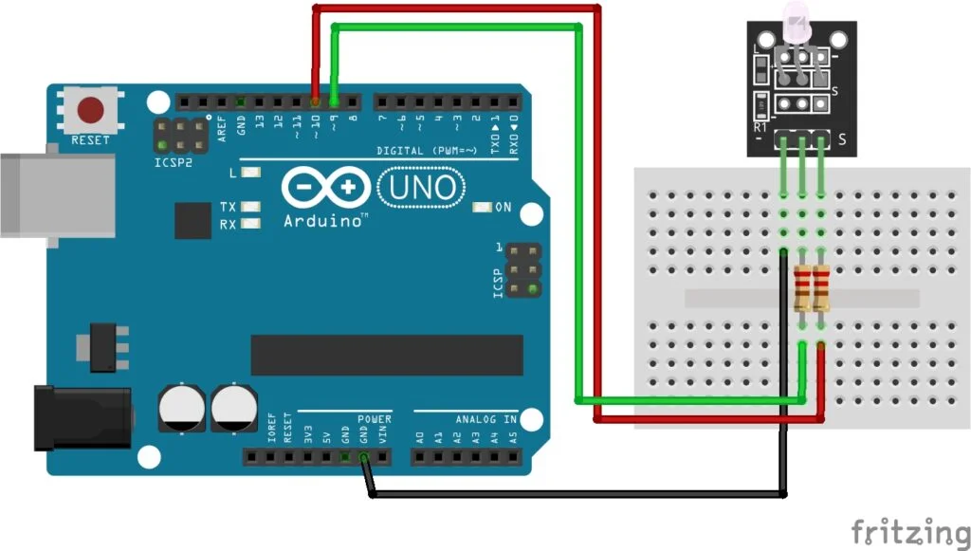

1. RGB LED\

Components Required:

Arduino board

RGB LED

Jumper Wires

Bread board

Program:

int red_led = 11;

int green_led = 10;

int blue_led = 9;

void setup() {

  pinMode(red_led, OUTPUT);

  pinMode(green_led, OUTPUT);

  pinMode(blue_led, OUTPUT);

  // put your setup code here, to run once:

}

void loop() {

  led_color(0,255,255);

  delay(1000);

  led_color(255,0,255);

  delay(1000);

  led_color(255,255,0);

  delay(1000);

  // put your main code here, to run repeatedly:

}

void led_color(int red_value, int green_value,int blue_value)

{

analogWrite(red_led,red_value);

analogWrite(green_led,green_value);

analogWrite(blue_led,blue_value);

}

Circuit Diagram:

